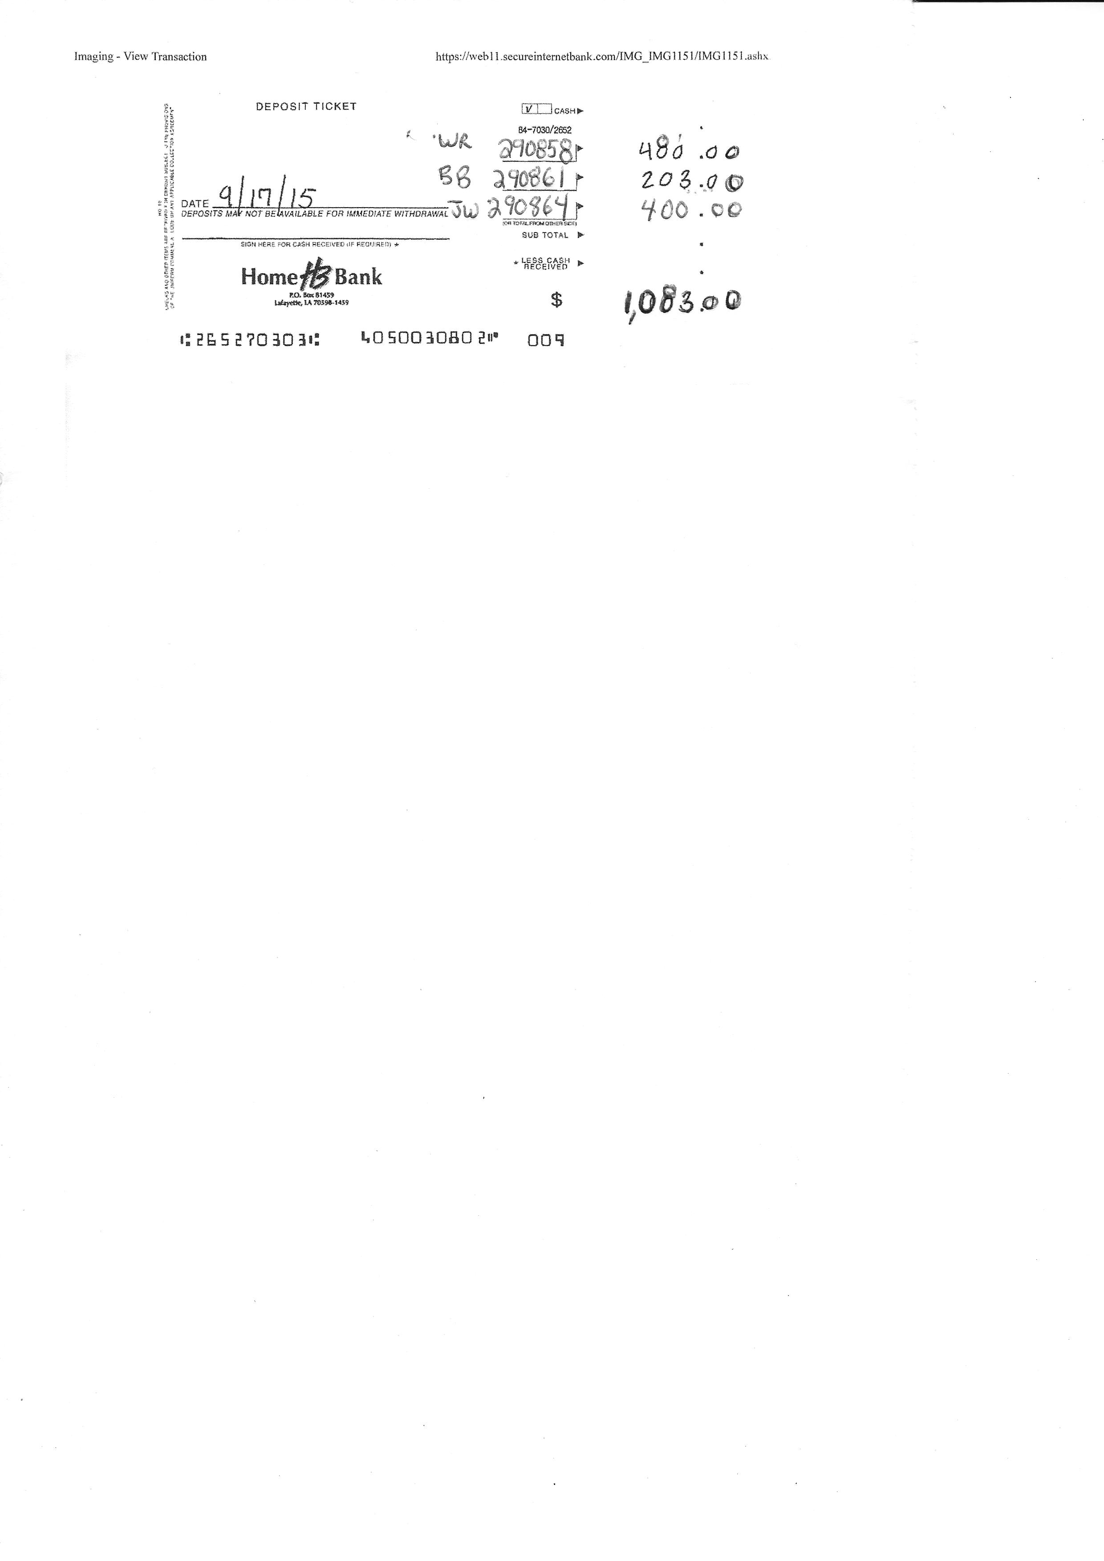
- Make all deposits at Home Bank. We will make fund transfers to FM Bank when needed.
- Write down Invoice Number (Important), Initials of the costumer, and Amount Paid.
- Maximum 3 invoices per Deposit Slip.
- Make the deposit ASAP after money is received (Not 2 weeks later). We are required to pay Sales Tax on a monthly basis so, it is critical to have money in the account quickly and it makes it easier to track in the accounting software.

Deposits can be made even if the bank is closed in the Night Deposit drop box. Make sure the money is in a sealed envelope with the Company Name written on the outside.

